|  |  |  |  |  |
| --- | --- | --- | --- | --- |
| Student Name: | Hanlin Cai |  | Student Name: | 蔡汉霖 |
| Maynooth ID: | 20122161 |  | Fuzhou University ID: | 832002117 |

## EE211 MATLAB Assign2:

Statement：

Alternatives：**A MATLAB/Simulink environment**

The data set given to me by the TA is shown below:

f_0 = 10; A1 = 6; A2 = 6; A3 = 6; k1 = 6; k2 = 8; h3 = 0.1;

All the Code & Picture were designed and created by myself,

and I never share with others.

Procedure 1

Picture for procedure1:

If we can assume the system is linear, we can model it by a linearized model. Just As shown in Pic-1:

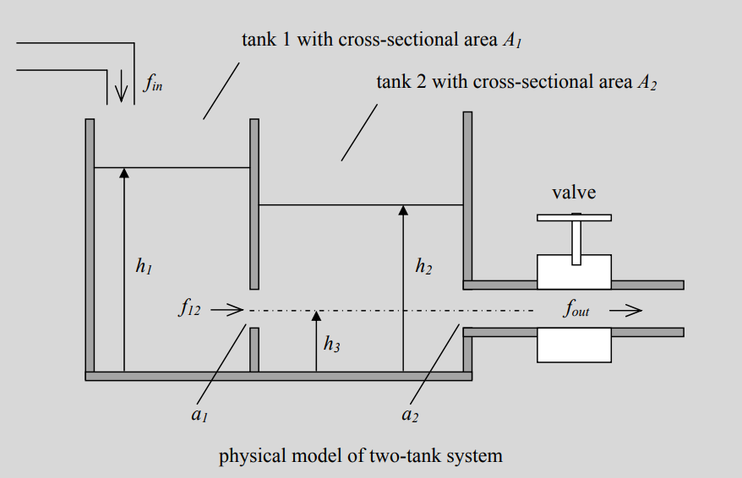

Pic-1 physical model of 2-tank system

Therefore, we can use the formula below:

Then, we can get the flow balance equations for each tank:

Since and ,we can get：

Finally, we can obtain the final dynamic model of the 2 tank system as follows:

Ultimately, we can plug the data into the formula:

Then at equilibrium . Hence:

So, we get:

At , the result is:

Now we obtain that:

Evaluating each of the derivatives gives:

Finally, in the same way, we can obtain that:

Hence, we obtain the following linear model approximation:

Where the numerical data is:

These are my solution of the analytical model and numerical application.

Procedure 2

Picture 2:

The simulation models are provided.

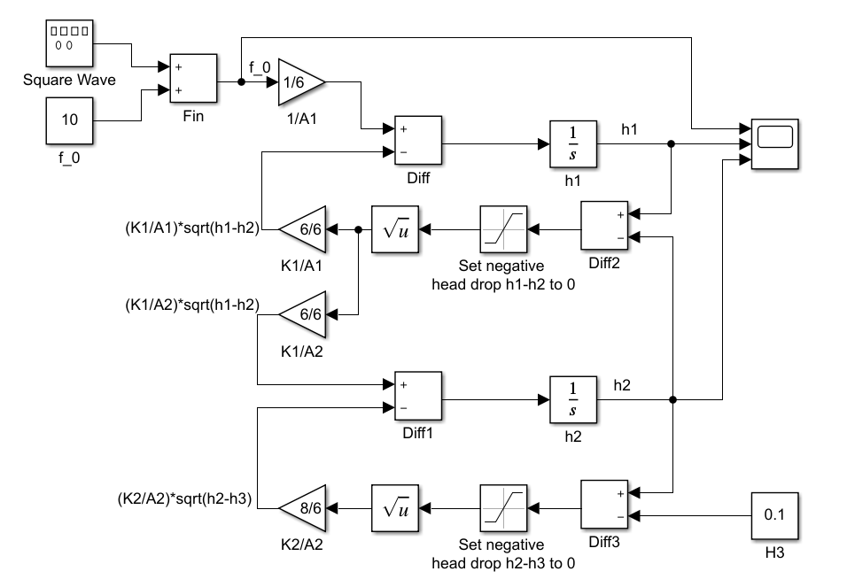

Pic-2 Simulink Modelling-1

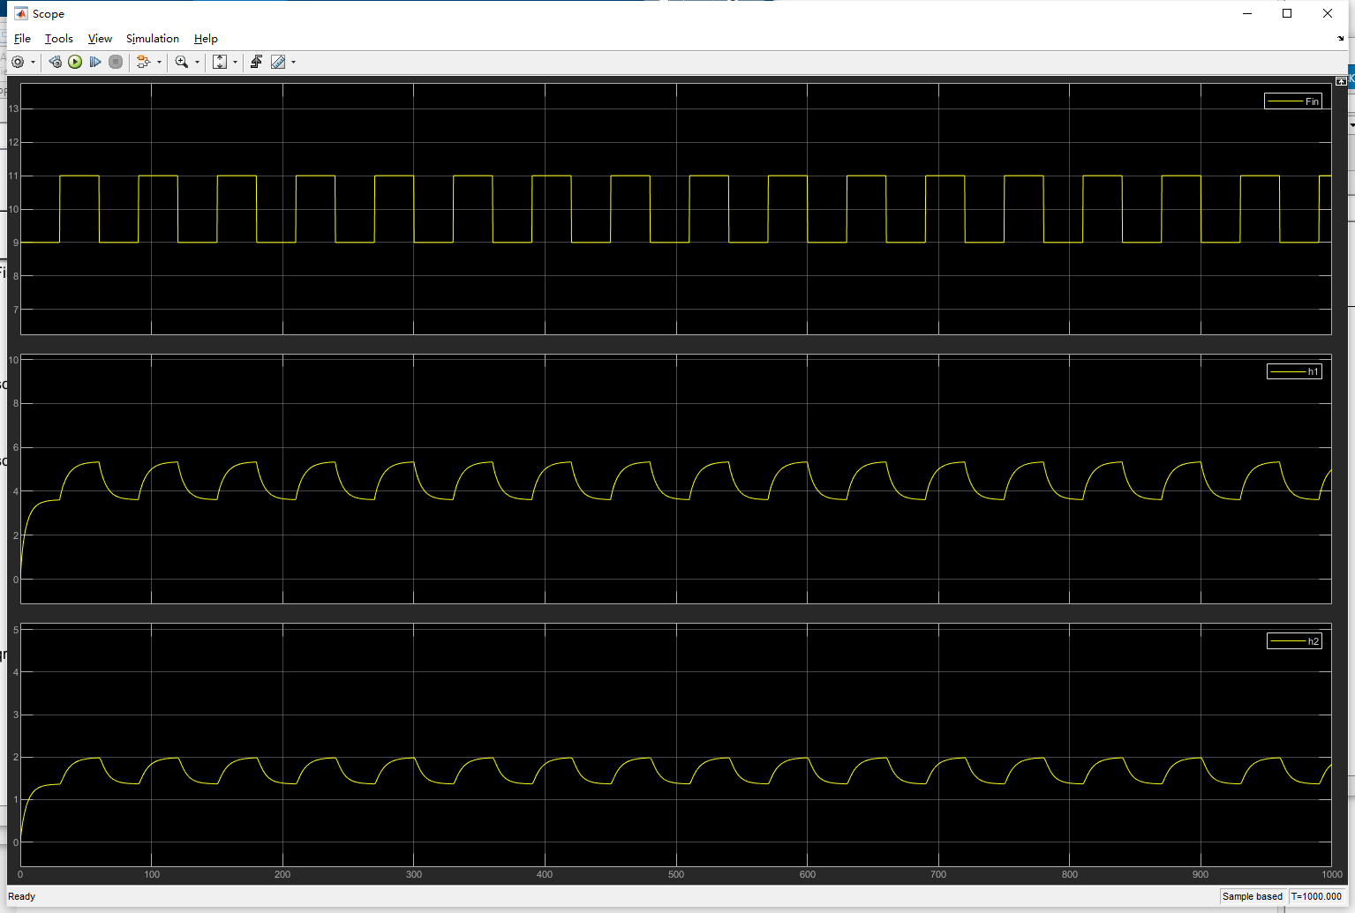

Pic-3 for dataset-1 (0.1*)

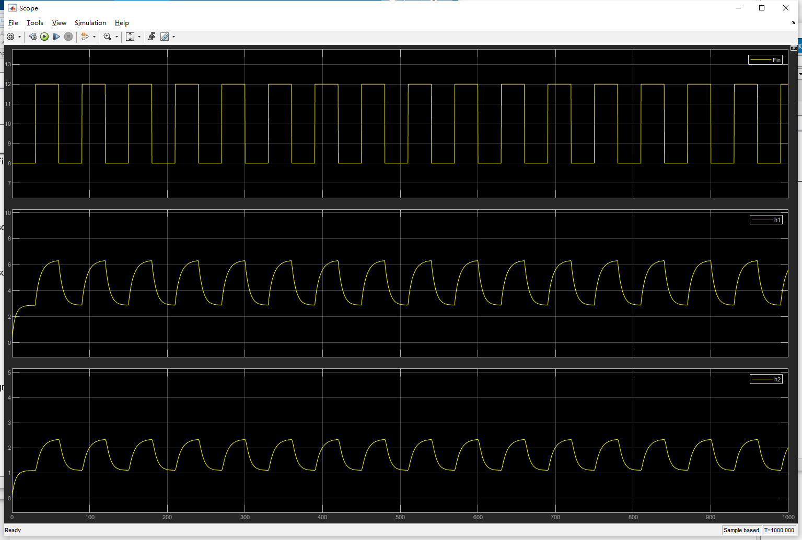

Pic-4 for dataset-2 (0.2*)

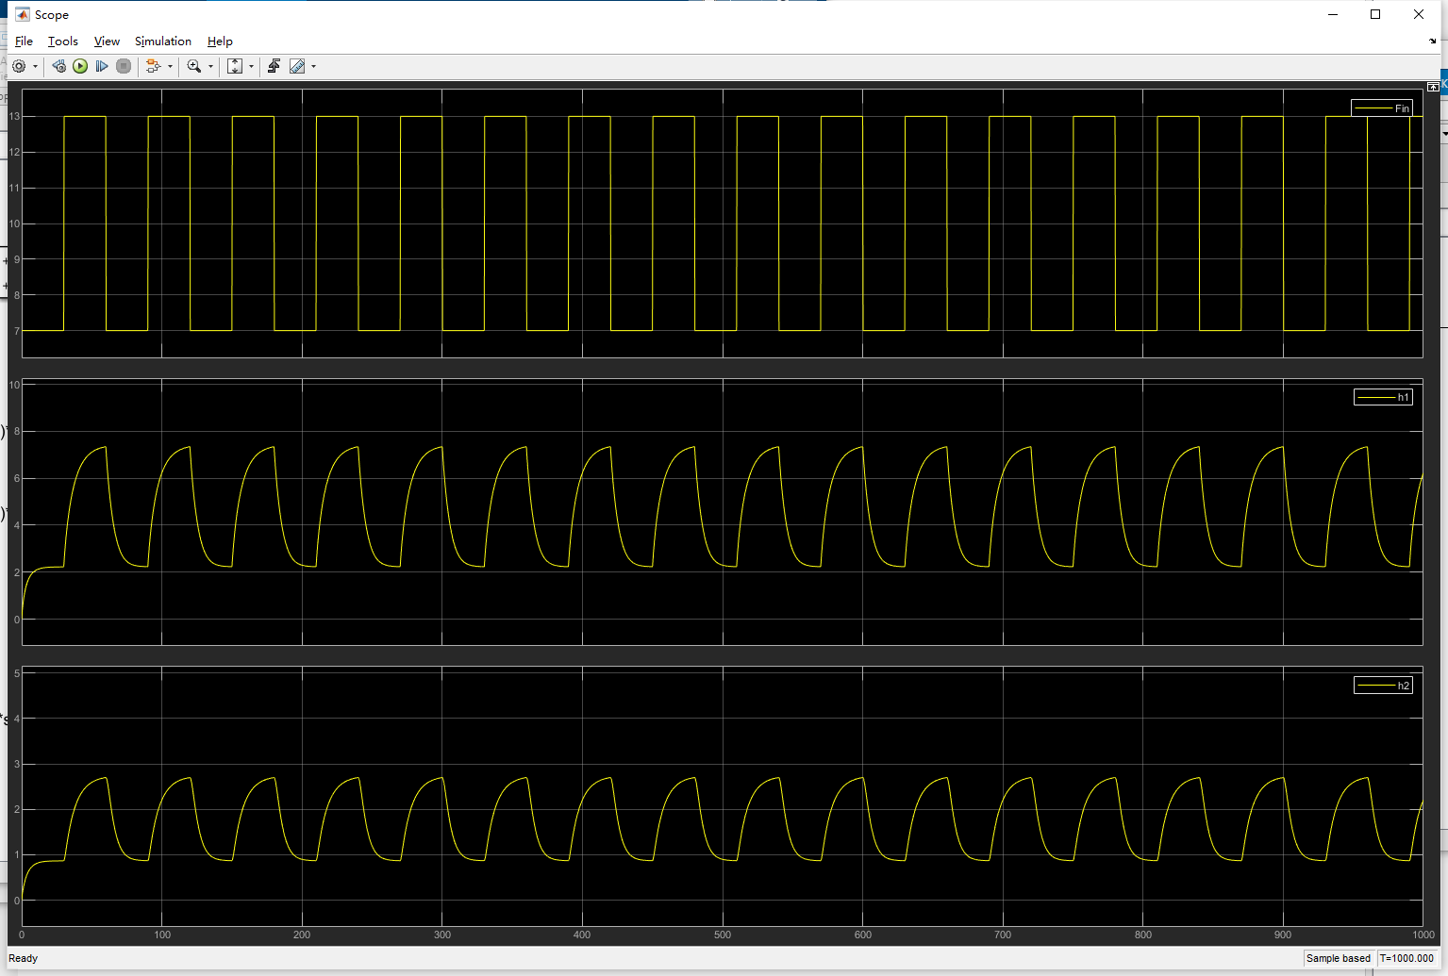

Pic-5 for dataset-3 (0.3*)

MATLAB CODE:

%% Matlab Assign2_1 by Hanlin Cai

% Plugging the data into the simulink model

f_0 = 10;

A1 = 6;

A2 = 6;

A3 = 6;

k1 = 6;

k2 = 8;

h3 = 0.1;

per1 = 60;

fre = 1/per1;

% amp1 = 0.1*f_0;

% amp2 = 0.1*f_0;

% amp3 = 0.1*f_0;

Procedure 3

Picture 3:

For the linearized model:

We have obtained its linear model approximation:

Then, we can use MATLAB to simulate the laminar model

State-space simulation shows the jitter of the approximate turbulence model near the equilibrium point:

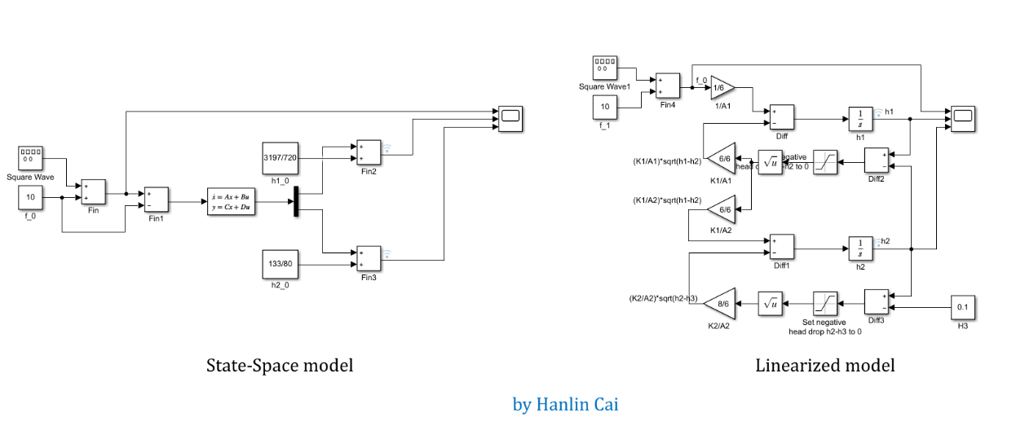

Pic-6 Stace-Space

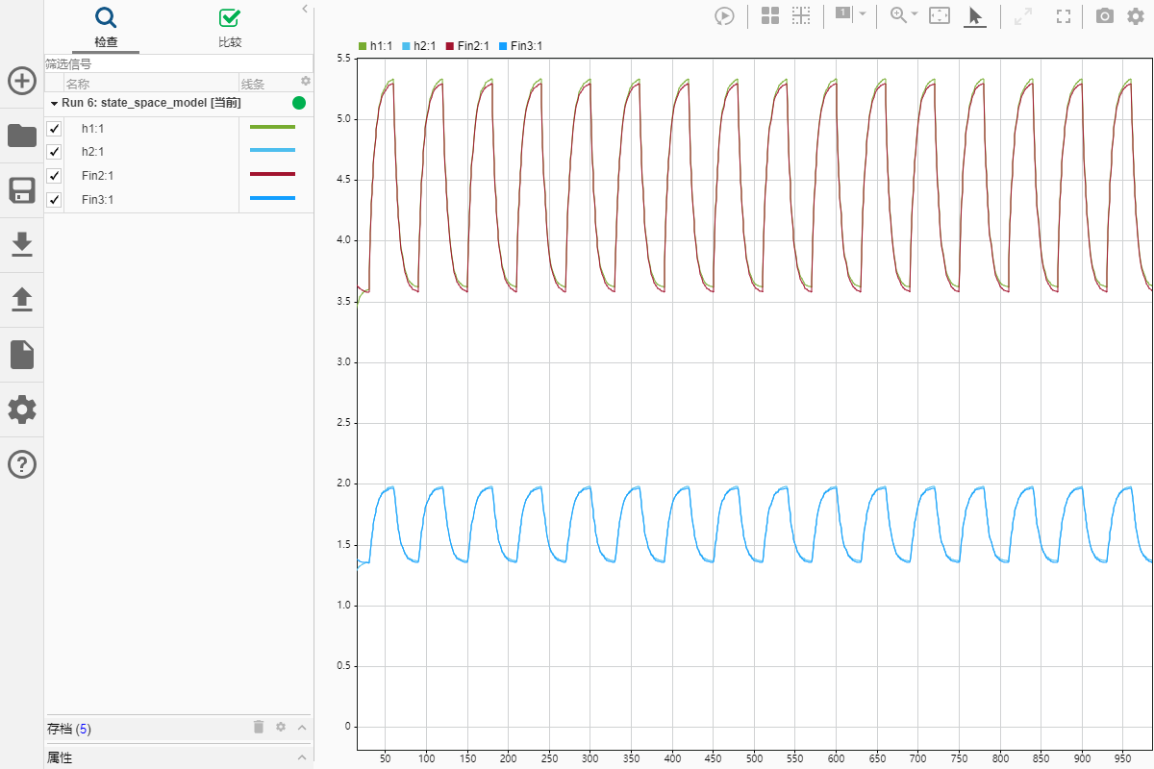

Pic-7 Comparison1

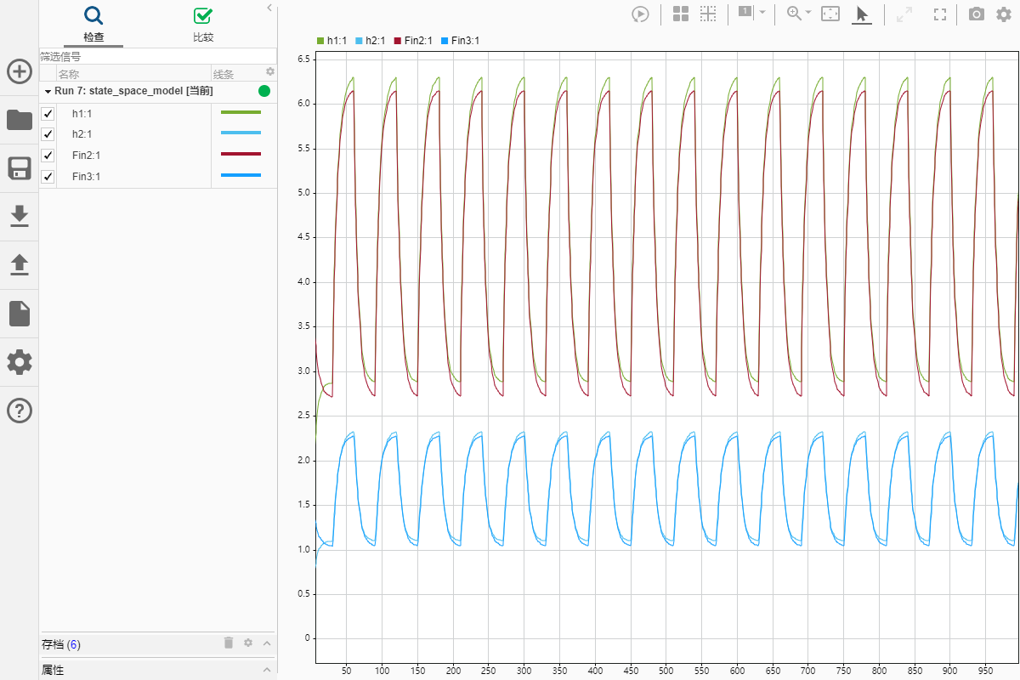

Pic-8 Comparison2

Procedure 4 Comment on the result

Through compare the responses obtained from procedure 2 and 3, I found that when the height is close to two extreme values (the highest point and the lowest point), the linearized model cannot accurately fit the state of the coupled tanks system. But in general, the fit between the two models is very high. Just as the Picture shown below:

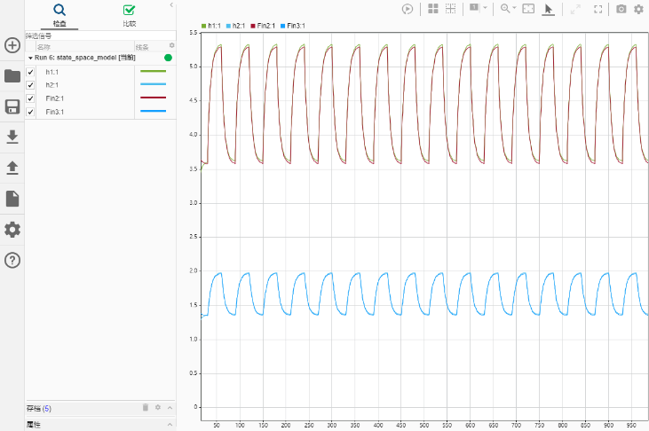 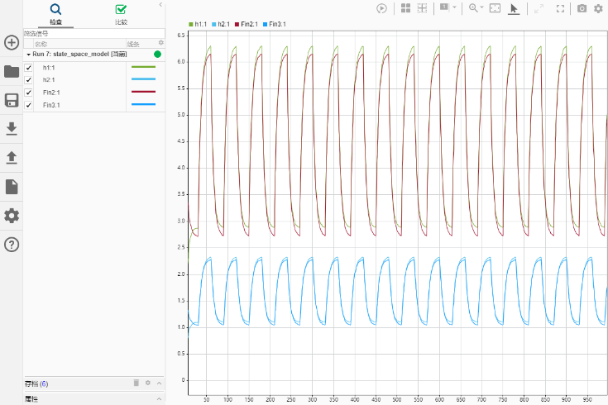

Pic 9-12

Procedure 5

For the laminar model:

Then, we can linearize this model by using the equilibrium we get:

After simplifying, we can obtain that:

Now, we can compare these 2 formulas:

Where = 10, = 6, = 6, so we can get that:

Ultimately, we can obtain the equilibrium ,

Then, we can plug the data into the MATLAB model for validation:

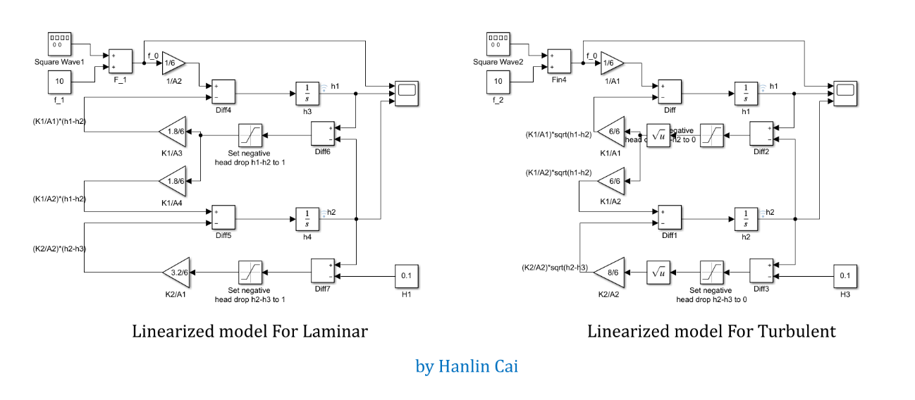

Pic-13

Now, comparing this model (using the linear system simulation) to that of the linearized (turbulent flow) model:

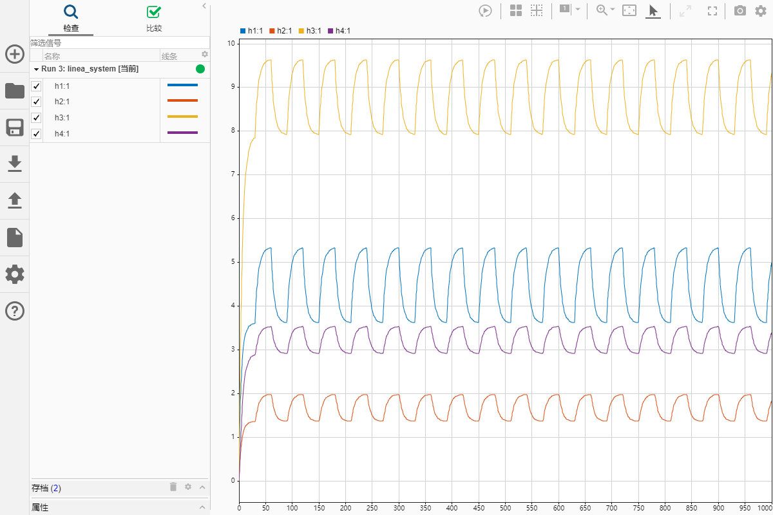

Pic 14

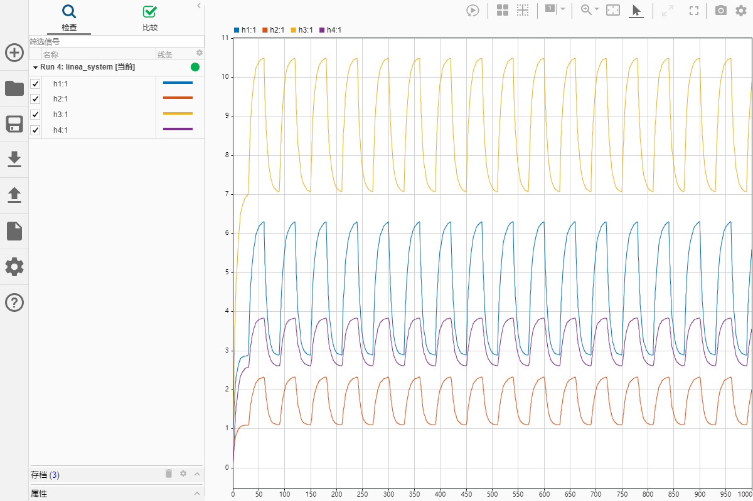

Pic 15

Comment: As predicted, the curves of the two models are similar, but the specific values are different. So, we consider this fitting condition is consistent with the theory.

**Addition:** the linear simulation models below are recreated by Hanlin Cai:

The linear model removed by the square root is a laminar flow model similar to the output of the turbulence model.

Pic-16 Simulink Modelling-2

Pic-17 for dataset-4 (0.1*)

Pic-18 for dataset-5 (0.2*)

Pic-19 for dataset-6 (0.3*)

Extra Question

If we use a different equilibrium input flowrate, we can see that:

In = 5:

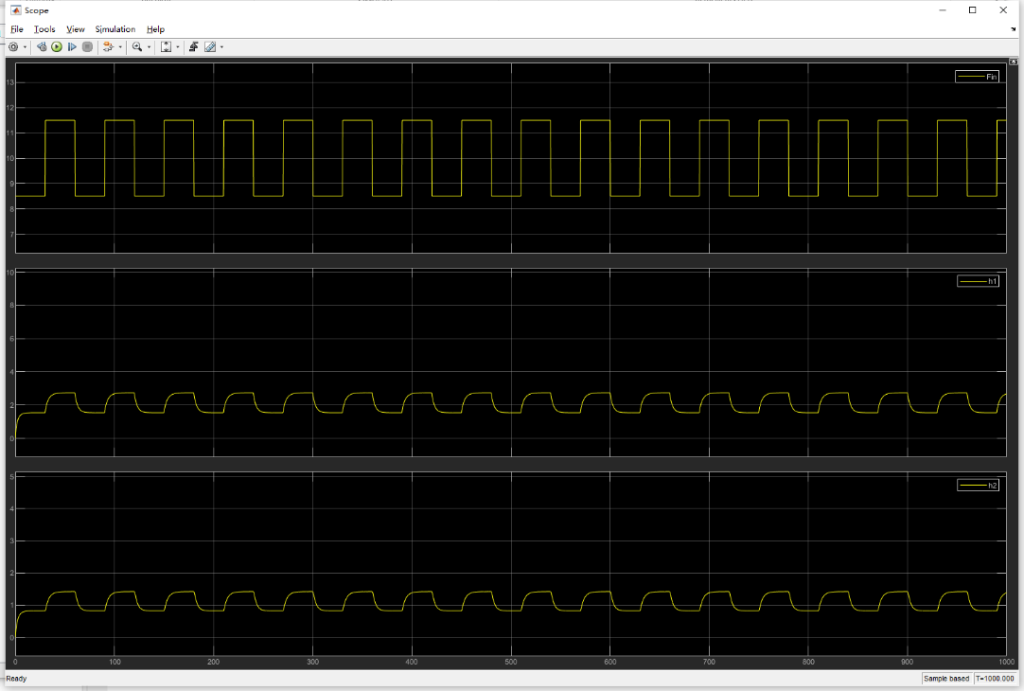

Pic 20

In = 10:

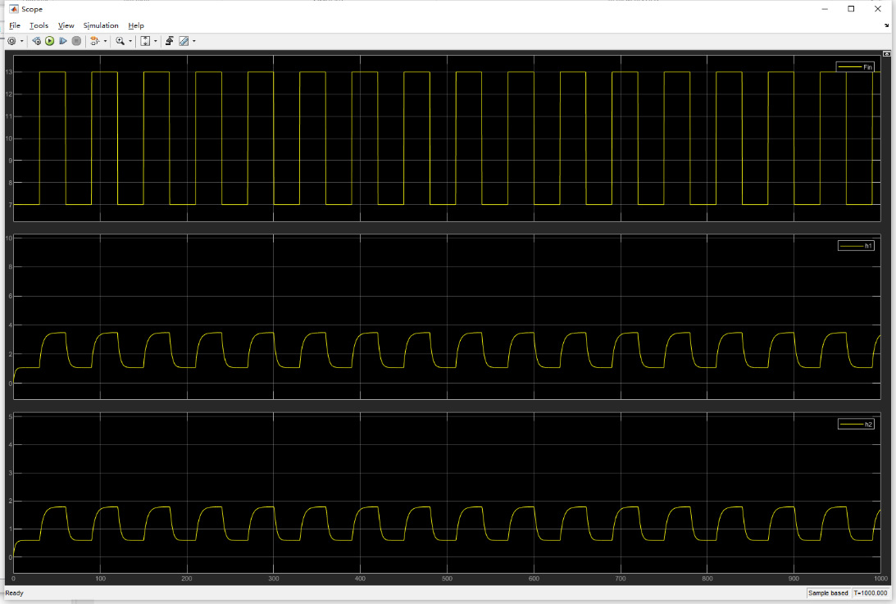

Pic 21

In = 20:

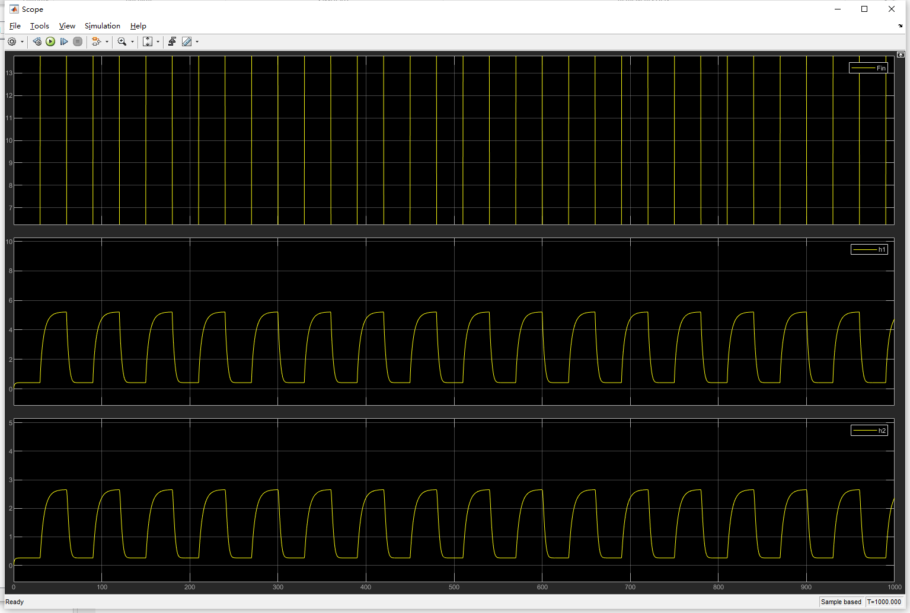

Pic 22

In = 30:

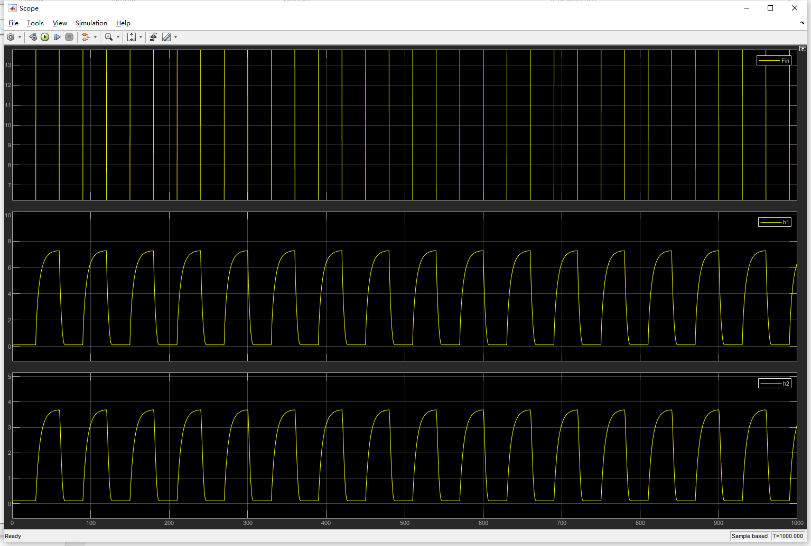

Pic 23

Comment: As pic 20-23 shown, as the input flowrate get bigger and bigger, the data in the pole get bigger too, but the speed of reaching the pole is almost constant. This tell that the speed of response is almost independent of the input flowrate.

A summary of what I gained in this Assignment

Through this assignment, I get familiar with how to simulate a complex model (Such as coupled tanks system in the assign2) by **MATLAB/Simulink**. Although this assignment was very difficult for me at the beginning, I finally finished it well through independent study and continuous trying.

Acknowledgement

I would like to thank my professor, **Zhicong Chen**, and my TA, **Xunfeng Lin**. I’m really appreciate for your grateful patience and wisdom! Without your help, I could not finish this difficult assignment well. Thank you!